Web server App server
1. Install nginx and run nginx on port number 81.
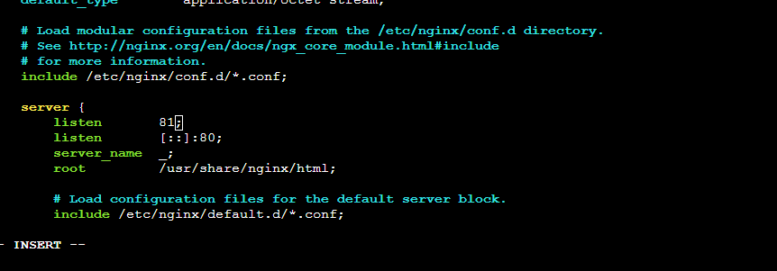
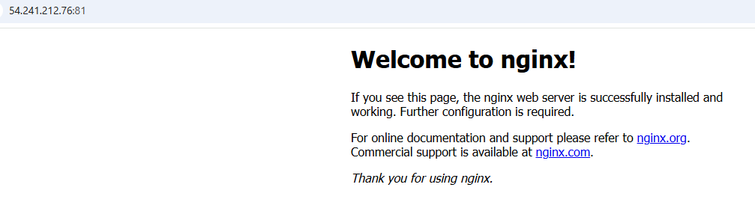
2. Deploy a sample index.html file on nginx.

3. Install Apache and run Apache on port number 82.
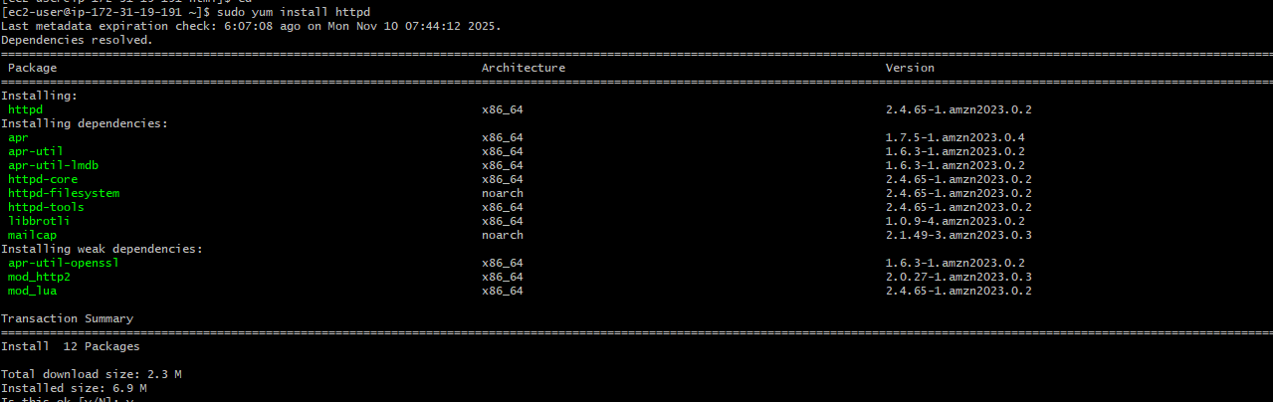

4. Deploy a sample index.html file on Apache.
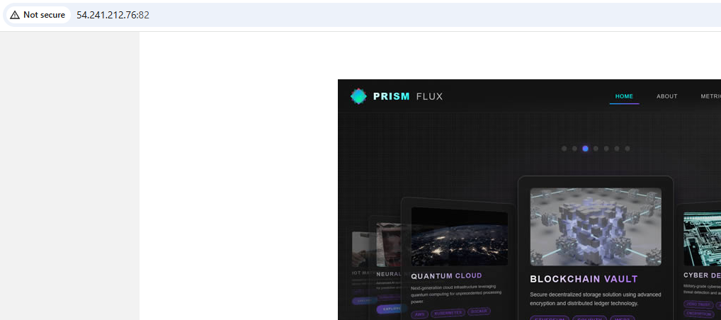

5. Install Apache tomcat on port number 8082
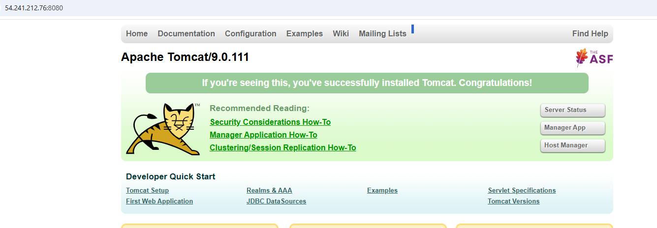
6. Deploy a sample app on webapps



7. Create a tomcat.service file for tomcat.
A tomcat.service file for Systemd can be created to manage Apache Tomcat as a service on Linux systems. This file should be placed in /etc/systemd/system/tomcat.service.
Here is an example tomcat.service file:
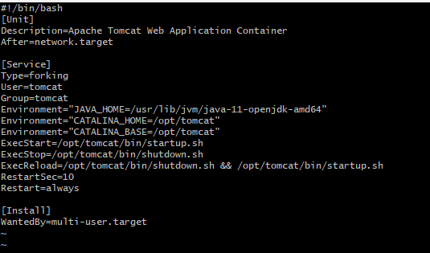
8. Configure HA Proxy server.

